CHECKLIST FOR EACH ARTICLE
Deadline for submission
Saturday: 05th Oct. 19
- Each annotation/summary should be 100 – 150 words
- Citation of the article in APA format
- State the purpose/goal/hypothesis/research question of the study (1-2 sentences)
- Describe the method of research (1-2 sentences)
- State the major findings/conclusion of the study (2-3 sentences)
- Explain how the source is relevant to your chosen topic (1-2 sentences)
- For your selected project topic choose 4 sources of information as references.
- 2 of these references must be from academic journals and 2 from newspapers/ magazines/ government reports/ government website.
- Make sure that the sources chosen, help you answer the question related to the topic you have chosen.
- Cite the sources in APA style. Write a concise annotation for each reference article in about 100 -150 words.
- The format is specified in the document.
- Information: Check the file “Checklist for Each Summary” to help you cover all the required points for writing a summary/annotation
- In first paragraph, you will write an introduction of your research topic (2-3 sentences).
- In second paragraph, you will write annotation/summary of 1st article (100-150 words).
- In third paragraph, you will write annotation/summary of 2nd article (100-150 words).
- In fourth paragraph, you will write annotation/summary of 3rd article (100-150 words).
- In fifth paragraph, you will write annotation/summary of 4th article (100-150 words).
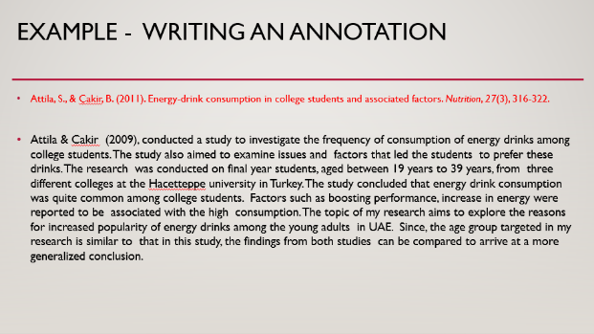

literature review - rubric
 | Exemplary (A)  (90-100) | Accomplished (A-/B+/B)  (80-89) | Developing  (B-/C+/C)  (70-79) | Beginning  (C-/D+/D)  (60-69) | 0 (F)  (0-59)
Citations  Weight- 20% | All the four sources used are correctly cited using APA format. There are no errors in formatting, style or information. | All the four sources used are cited using APA format. There are few errors in formatting, style or information. | All the four sources used are cited. The APA format is incorrectly used and /or there are some errors in formatting, style or information. | Most sources are incorrectly cited, and the APA format is incorrectly used and/or there are several errors in formatting, style or information. | Sources used are not cited.
Content of annotations  Weight-40 % | All annotations clearly mention all the significant aspects of the study such as hypothesis/ research question/purpose of study, method of research, major findings /conclusion of the research and relevance of the source to the topic. | Most  annotations  mention significant aspects such as hypothesis/ research question/ purpose of study , method of research, major findings /conclusion of the research and relevance of the source to the topic | Some  annotations mention significant aspects such as hypothesis/ research question/central theme, method of research, conclusion of the research and relevance of the source to the topic or  Some annotations are lacking  in completeness  . | Most  annotations are  lacking in  Completeness. Most of the significant aspects such as hypothesis/ research question/central theme, method of research, conclusion of the research and relevance of the source to the topic are not discussed. | All annotations  are lacking in  Completeness or the annotations are missing.
Sources  Weight-20% | Information is gathered from 4 sources and the  sources used  are highly relevant to the topic and research based | Information is gathered from 4 sources but only 3 of the  sources used  are relevant to the topic and research based | Information is gathered from at least 3 sources but only 2 of the  sources used  Are relevant to the topic and research based. | Information is gathered from at least 2 sources both of which are relevant to the topic and research based. | Information is gathered from only one source which is not research based or Sources used are irrelevant to the topic and are gathered from non-reliable websites /blogs.
Language and Grammar  Weight-20% | Almost no language, grammar and spelling errors. Excellent clarity in the writing. | Minor errors in language/grammar and spellings. There is good clarity in the writing. | There are significant language/grammar and spelling. Some part of the writing needs more clarity. | Several errors in language/grammar and spelling. Most of the ideas are not clearly conveyed. | Lot of errors in language/grammar and spelling. There is no clarity in the writing/ meaning is unclear.

